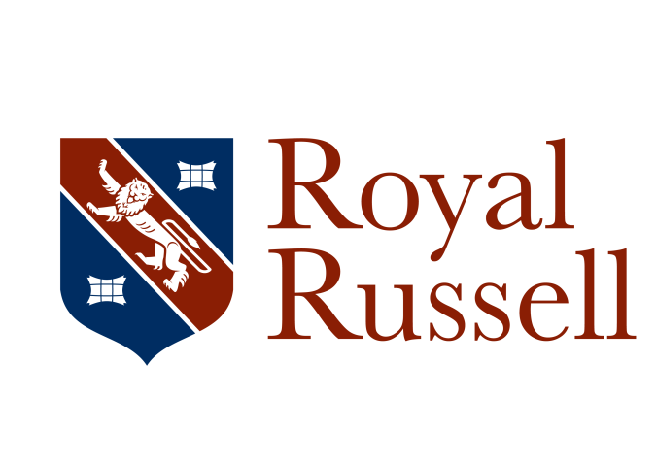

Co-educational boarding and day school (HMC)
1000+ pupils (3 to 18) 200 in Sixth Form

Teacher of Maths 0.6 fte - 1 term maternity cover from January 2021 with the possibility of extension

Can you help our students to excel in their learning of Mathematics? Our dynamic and high-performing teaching team needs a Maths specialist able to teach KS3 to GCSE, inspiring students with a love of learning about Maths.

If you are an innovative and inspirational part time teacher with passion and enthusiasm for your subject, who is committed to achieving high standards within a successful department, then we would love to hear from you.

Royal Russell is an HMC/IAPS co-educational school with over 1000 pupils between the ages of 3 and 18, situated on a beautiful green campus of 110 acres in the Shirley Hills near Croydon. We have over 150 boarding students in the Senior School, and are proud of our day and boarding facilities that rank amongst the best in the South of England. Our pupils, parents and staff experience a warm and friendly environment with strong pastoral care for every pupil alongside a comprehensive co-curricular and enrichment programme. We aim to build on this alongside improving academic success to continue to be the family school of choice in South London. The Independent Schools Inspectorate (ISI) has recently judged the school as ‘excellent’ in all areas and in October 2018 we successfully passed a full ISI compliance inspection.

Mathematics is one of the strengths of the school, with consistently excellent outcomes and high value added at GCSE and A level. Maths is the most popular A level subject within the school, and students consistently provide positive feedback about their Maths learning. As well as delivering great lessons, the department provides additional stretch and challenge for the most able through extension opportunities, and also provides small-group support for students who need extra time to develop their skills.

You will become a central part of our diverse, enthusiastic and energetic family. The strength of community at Royal Russell is paramount to the success of every individual and we strongly believe that we learn and achieve together. You will be a well-qualified and inspiring teacher with outstanding subject knowledge, able to teach confidently from Year 7 through to GCSE and ideally to A level to join our dynamic and friendly Maths department. This is a maternity cover position working Monday-Thursday each week until April 2021, with the possibility of extension. Alongside teaching Maths across Key Stage 3-5, you will also support students as a tutor, and in a range of co-curricular activities. This role requires an enthusiasm for the subject, alongside experience, dynamism, teamwork and dedication and a willingness to contribute to the extra-curricular programme and support the pastoral life of our community.

Royal Russell offers excellent benefits including a competitive salary on our own salary scale which is above SNS and includes allowances for specific pastoral and academic responsibilities. As part of the vibrant community of the historic Royal Russell School, you will work in our beautiful green parkland estate with easy access to transport links. Teachers automatically join the Teachers’ Pension Scheme (TPS), or you may opt into an alternative defined contribution pension with free life cover. In addition you will have access to free car parking, free meals, a discount on School fees, and the use of our sporting and gym facilities. Full details of our staff benefits and recruitment procedures can be found on our School recruitment page at https://www.royalrussell.co.uk//vacancies

A fully completed application form which includes a supporting statement outlining the extent to which you meet our requirements as set out in the person specification included in the job description, and details of two referees, one of which should be a current or most recent employer should be emailed to hr@royalrussell.co.uk. References may be taken up before interview.

Applications will be considered on receipt and should arrive no later than 12 noon on Monday 12 October 2020. Interviews will be held at the school later that week. If you have not heard from us by Friday 16 October 2020 you should presume that you have not been successful on this occasion.

The School is committed to safeguarding and promoting the welfare of children. All appointments are subject to a satisfactory enhanced Disclosure and Barring Service check (including a check against the Children’s Barred List) and other pre-employment screening including a check on the Secretary of State list of prohibited staff, references and medical fitness.

