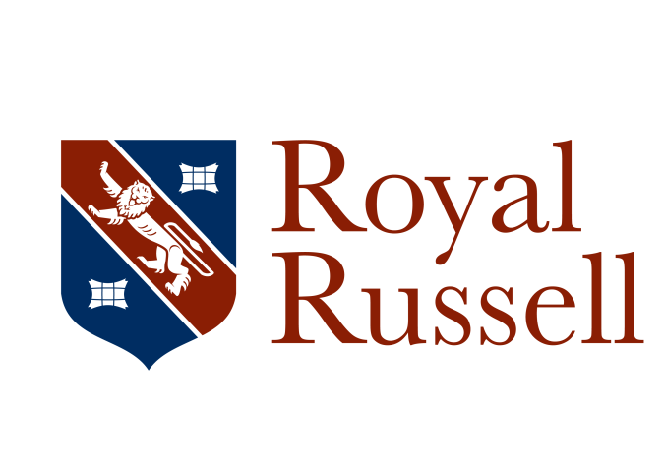

**Mr C J Hutchinson**

Headmaster

Tel: 020 8657 3669

headmaster@royalrussell.co.uk

Headmaster’s Newsletter Friday 15 May 2020

Dear Parents and Friends,

The newsletter this week is in two parts:

The first focuses on our Chapel Service, Assembly and the upcoming Wellbeing week.

The second gives an update on the School’s response to recent government announcements and introduces a Parent Survey on our remote learning programme.

**Part I**

I hope that many of you have already enjoyed a chance to view the Chapel service led by our Senior Prefects this week. If you have not been able to do so, you can view it [here](https://www.youtube.com/watch?v=VNSJUigsQxQ&feature=youtu.be). My thanks to Jack, Megan, Nikita, Vlad, Philip, Anna, Bibienne, Erika, Imran, Ali, Jada, Charlie and Matt for all their thoughtful advice and for their brilliant contributions in the service of the School this year.

In the service, the Heads of School read from the poet Ben Okri and, given the positive, transformative and forward looking message, I thought that I would share it here again

*Will you be at the harvest,   
Among the gatherers of new fruits?  
Then you must begin today to remake  
Your mental and spiritual world,  
And join the warriors and celebrants  
Of freedom, realizers of great dreams.   
You can’t remake the world  
Without remaking yourself.  
Each new era begins within.  
It is an inward event,  
With unsuspected possibilities  
For inner liberation.*

*We could use it to turn on  
Our inward lights.  
We could use it to use even the dark  
And negative things positively.  
We could use the new era  
To clean our eyes,  
To see the world differently,  
To see ourselves more clearly.  
Only free people can make a free world.  
Infect the world with your light.  
Help fulfill the golden prophecies.  
Press forward the human genius.  
Our future is greater than our past*

Ben Okri also said, “The most authentic thing about us is our capacity to create, to overcome, to endure, to transform, to love and to be greater than our suffering.” Given our current national and international circumstances and the challenges we face in responding to the covid-19 pandemic, this sense of resilience and victory over adversity has been very strong in many of the conversations I have held with colleagues, parents and pupils this week.

I am delighted to draw your attention to this year’s Wellbeing Week, which will take place from Monday 18 to Sunday 24 May 2020. The theme of this campaign will be Kindness.

The Wellbeing Week has been organised by:

Mrs Hart, Mr Alex Porter, Mrs A Netherway and the Student Wellbeing Support Group, who say:

“One thing that we have seen all over the world is that kindness is prevailing in these uncertain times. We have seen that despite our current situation communities have come together in a show of support for one another. Not only does this benefit others in our communities, but it is good for our own mental health and wellbeing to provide support to others as it can help reduce stress and improve emotional wellbeing.”

This week’s assembly introduces the Wellbeing Week and is available [here](https://www.youtube.com/watch?v=9eHJifyCHXQ&feature=youtu.be).

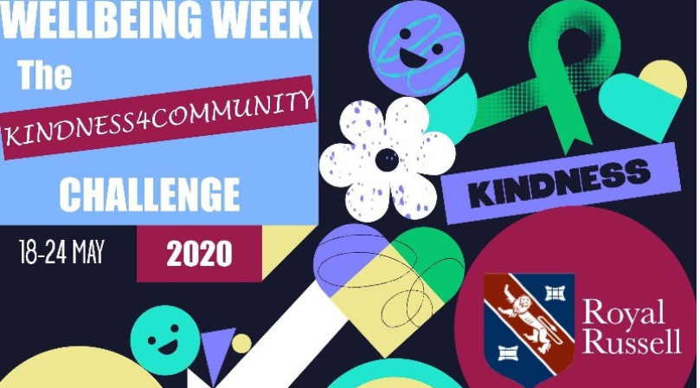

As part of Wellbeing Week, students will be challenged to complete the Royal Russell 'Kindness 4 Community' challenge with any [donations made in support](https://www.justgiving.com/crowdfunding/kindness4communityroyalrussell) of them going to [the Rowdown Foundation,](https://www.rowdownfoundation.org.uk/) a local Charity based in New Addington which supports talented children to achieve their goals and ['Off the Record'](https://www.talkofftherecord.org/), a local youth counselling charity.   
You will be able to follow our progress on [Twitter](https://twitter.com/Royal_Russell?ref_src=twsrc%5Egoogle%7Ctwcamp%5Eserp%7Ctwgr%5Eauthor)  and [Instagram](https://www.instagram.com/royal_russell_school/?hl=en) and through #RoyalRussellKindness, and please send us updates and photos of you completing the challenges to [reception@royalrussell.co.uk](mailto:reception@royalrussell.co.uk) .   
   
Throughout the week, pupils, parents and staff will receive daily communications detailing their challenges. Each day there will be 4 challenges available to complete. We would love to see as many of you completing as many a day as possible, and don't forget to send us photos or videos of your favourite activity of the day via Facebook, Instagram or Email.    
The four daily challenges will be inspired by the following themes:

**Staying connected Home/Community Keeping active Reasons to Smile**   
We can't wait to see you all completing these challenges as part of Wellbeing Week 2020. We hope you enjoy this new idea and that you find the 'Kindness 4 Community' challenge fun and fulfilling, don't forget to show us your progress across the week!

**Part II**

This sets out a summary of the next (baby) steps that we plan to take in reopening the School on site, when it is safe to do so.

On Sunday 10 May the Prime Minister set out a roadmap for the easing of restrictions in England. On Monday 11 May, the UK Government released its document [“Our Plan to Rebuild”](https://www.gov.uk/government/publications/our-plan-to-rebuild-the-uk-governments-covid-19-recovery-strategy/our-plan-to-rebuild-the-uk-governments-covid-19-recovery-strategy) which was accompanied by an [FAQ document](https://www.gov.uk/government/publications/coronavirus-outbreak-faqs-what-you-can-and-cant-do/coronavirus-outbreak-faqs-what-you-can-and-cant-do). Later on Monday the DfE published guidance on plans to open education and childcare settings to more children from 1 June.

**The key points from these documents are:**

• As the Prime Minister announced on Sunday evening, by 1 June at the earliest primary schools in England may be asked to open to children in Nursery, Reception, Year 1 and Year 6.

• Secondary schools, sixth forms and colleges are also being asked to “offer some face-to-face support to supplement the remote education of year 10 and year 12 students who are due to take key exams next year”.

• The government will monitor progress towards reducing the spread of the virus over the next three weeks. Schools and colleges will only be asked to open more widely on 1 June if the virus “stays on the downward slope” and R remains below 1.

• Early Years settings are also being asked to open for all children from 1 June.

• The government’s ambition is then to “bring all primary year groups back to school before the summer holidays, for a month if feasible”, though this will be “kept under review”.

• There are currently no plans to reopen secondary schools for other year groups before the summer holidays.

• Vulnerable children and children of critical workers will continue to be able to attend schools, colleges and Early Years settings.

We are all acutely aware that moving to welcome more pupils on site is a complex and multi-layered process which will require careful thought and preparation. I have been working with the School Leadership Team this week to review the published guidance and the advice of our professional consultants, to put plans into place for the safe return of some staff and pupils.

**The Royal Russell Plan**

The Royal Russell Plan for reopening the School will now be built around the following points, which are all subject to change, if the UK Government or other circumstances dictate!

1. There will be no change to our current offering to pupils before Monday 1 June.
2. We will continue to offer our provision for the children of Key Workers, which has been running successfully, on site, since Tuesday 24 March.
3. We will be ready to open the Junior School for Year 6, Year 1 and Reception on Monday 1 June.

We will plan to be ready to open for other Junior School year groups later in June.

1. We will be ready to offer some on site provision for Year 10 and Year 12 pupils after half term, once the

In the Senior School, for those pupils in Year 10 and Year 12, we will be outlining further details of how we might seek to operate on site after half-term and seeking further information from parents relating to this early next week.

1. We will consider plans for offering some on site experiences for other Senior School Year Groups later in June.
2. We recognise that we must preserve integrity of our remote learning programme so that pupils who remain at home, for whatever reason, will not be disadvantaged. We will therefore continue to offer our remote learning programmes to all year groups, so that those who are not in School can have equal access to the curriculum.

We continue to review our remote learning offer and are using the expertise of [RS Academics](https://www.rsacademics.com/) to capture feedback from parents in all year groups. We invite you to complete this survey here: [Royal Russell - Home Learning Survey (Parent Senior)](https://linkscan.io/scan/ux/aHR0cHM6Ly9yc2FjYWRlbWljcy5mcmExLnF1YWx0cmljcy5jb20vamZlL2Zvcm0vU1ZfYTVhaU16a09DMUM4d0laP3NjPTEzNw==/BD110D3FC1E398D60C16EA6A5C37ADA0063F2F75CF407AC959F9EB7A4D88F363?c=1&i=1&docs=1)

**Risk Assessment**

The School Leadership Team are now completing a detailed Risk Assessment restarting our teaching provision on site. This risk assessment is a necessary step to ensure the safety of all of our staff and pupils and to consider all aspects of the UK Government’s advice for Schools regarding, cleaning, handwashing and hygiene, helping people to work from home, social distancing and managing transmission risk. Ultimately, we will publish this Risk Assessment to all members of the School Community on the School website.

I know that parents will appreciate that, although we are an independent school, Royal Russell is absolutely bound by national guidelines in our response to the challenge of restarting our provision on site. As there is still a great deal of uncertainty around some of the national guidelines, we will be sending out more detailed information as soon as we are able.

With my very best wishes,



C J Hutchinson

Headmaster