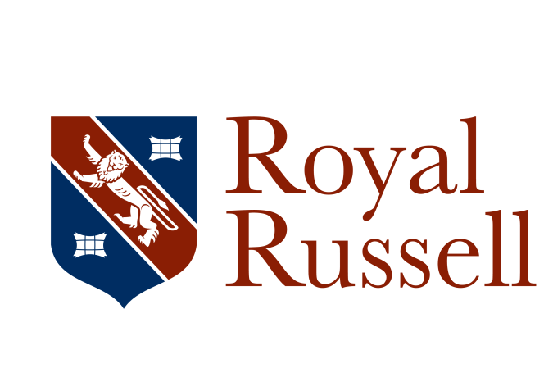

Co-educational boarding and day school (HMC)
1000+ pupils (3 to 18) 200 in Sixth Form

Business Administration Apprentice

Would you like to gain experience supporting multiple departments in a busy school environment? If you’re well-organised, customer focused and looking to develop your communication skills this could be the role for you!

We are seeking a first class Business Administration Apprentice to provide an exceptional front of house service. You will be make positive first impressions on a daily basis as you greet prospective parents, teachers and guests. You will be using your customer service skills to provide an efficient and effective switchboard service as well communicating efficiently via email and in person. This role will enable you to communicate with various stakeholders at all levels.

You will deliver a range of administrative tasks to contribute to the overall efficiency of the School. You will gain exposure to various departments including HR, Finance, Admissions and Operations and you should complete the apprenticeship with a full understanding of the operational structure at an independent school.

This exciting opportunity offers excellent benefits including joining a team of dedicated, supportive and friendly staff, free meals, free car parking, working in our beautiful green parkland estate with easy access to transport links, a discount on School fees and the use of our sporting and gym facilities, all combined with the opportunity to be part of the vibrant community of the historic Royal Russell School. Full details of our staff benefits and recruitment procedures can be found on our School recruitment page at https://www.royalrussell.co.uk/vacancies.

A fully completed application form which includes a supporting statement outlining the extent to which you meet our requirements as set out in the person specification, and details of two referees, one of which should be a current or most recent employer should be emailed to hr@royalrussell.co.uk. References may be taken up before interview.

Applications will be considered on receipt and should arrive no later than 12 noon on Monday 12 October 2020. Interviews will be held in the w/c 26 October 2020.

This vacancy is offered with the possibility of it becoming a full time post within the operations team on a permanent basis to develop their career.

The School is committed to safeguarding and promoting the welfare of children and all appointments are subject to a satisfactory enhanced Disclosure and Barring Service (DBS) check (including a check against the Children’s Barred List), and other pre-employment screening including references and medical fitness.

