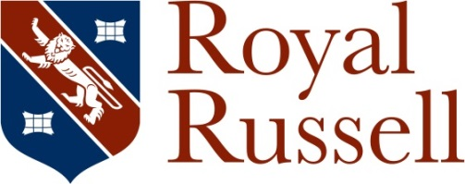

Receptionist/Administrative Assistant (0.5381 fte)
c£11,900 pa
25 hours pw worked 1pm and 6pm Monday-Friday during term-time (36 weeks pa)
Maternity Cover – 1 Year Contract
Start asap

Are you an experienced Receptionist, or a customer service professional? We are looking for a part-time maternity cover colleague to join our team of two who cover Reception during the School day, providing an efficient, pro-active and effective telephone and reception service for our visitors.

You will be professional, welcoming and helpful, with a customer-focused approach to the role you will guarantee that our pupils, parents, staff and visitors receive the very best level of customer care and warmth. You will welcome visitors, handle incoming queries to the reception desk, receive and relay messages to staff members and ensure that safeguarding and security procedures are followed at all times. You will also handle incoming and outgoing post and deal with couriers and taxis. You will act as the first point of contact for visitors to the School and so the ability to make a positive first impression is vital.

Royal Russell is a highly respected independent co-educational day and boarding school in South Croydon with over 1,000 pupils aged from 3-18. We are proud of our facilities that rank amongst the best in the South of England and our pupils, parents and staff experience a warm and friendly environment with strong pastoral care for every pupil alongside a comprehensive co-curricular and enrichment programme. Our Junior and Senior Schools share our beautiful 110 acre university style campus. We have excellent public transport links - we are only 10 minutes from the Croydon town centre by tram (Coombe Lane tram stop served by the New Addington tram is opposite the School entrance), and 30 minutes from central London.

You will already have experience in a busy reception or customer facing role and be able to ‘think on your feet’ and work quickly. If you have excellent communication and IT skills, with an eye for detail, feel confident being the first point of contact with prospective and existing pupils and parents, teachers or guests and can develop and maintain good working relationships with all stakeholders, this could be the role for you.

In addition to the benefit of working with a friendly staff group, we offer:-
- free life cover
- immediate access to a non-contributory pension scheme with 7% employer contributions,
- free parking,
- free lunch,
- working in our beautiful green parkland estate,
- use of our on-site tennis courts, swimming pool and gym facilities free of charge,
- a discount on School fees including breakfast and after school clubs.

Please visit http://www.royalrussell.co.uk/vacancies for further details about our School, the role and the application process. To apply, you will need to submit a fully completed application form, taking care to ensure that your supporting statement outlines the extent to which you meet our requirements as set out in the person specification, and details of two referees, one of which should be a current or most recent employer, to hr@royalrussell.co.uk. References may be taken up before interview. Applications will be considered on receipt and should arrive no later than 12 noon on Monday 12 October 2020. Interviews will be held the week commencing 19 October 2020 with an anticipated start date of 2 November 2020 subject to pre-employment checks. We reserve the right to interview at any point during the recruitment process so early applications are encouraged.

The School is committed to safeguarding and promoting the welfare of children and all appointments are subject to a satisfactory enhanced Disclosure and Barring Service (DBS) check (including a check against the Children’s Barred List), and other pre-employment screening including references and medical fitness.

