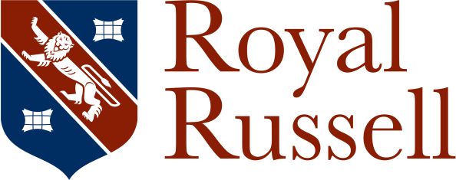

This pack contains all the forms which need to be completed for our boarding pupils starting at Royal Russell School in September 2024.
Should you have any queries please contact Mrs Karen Sanchez, Senior School Registrar – Boarding. Ph: + 44 (0) 20 8657 4433 ext. 282. Email: ksanchez@royalrussell.co.uk

All forms must be completed by the parents and/or guardian before
14th June 2024
Please return the forms by email to admissions@royalrussell.co.uk

Name of Forms | Please tick when completed
- Checklist
- Medical Information Form and Doctors Assessment
- Permission to Leave Grounds and Annual Trip Consent Form
- Arrival Information (this must be sent as soon as travel arrangement are known)
- International Fee Payment Instructions
- Instrumental and Vocal Tuition (to be completed ONLY if pupil wishes to take lessons – additional charges apply for these lessons)



www.royalrussell.co.uk
Royal Russell School, Coombe Lane, Croydon, CR9 5BX Incorporated with limited liability in England as Russell School Trust No. 1163246
Registered office as above. Registered Charity No. 271907

